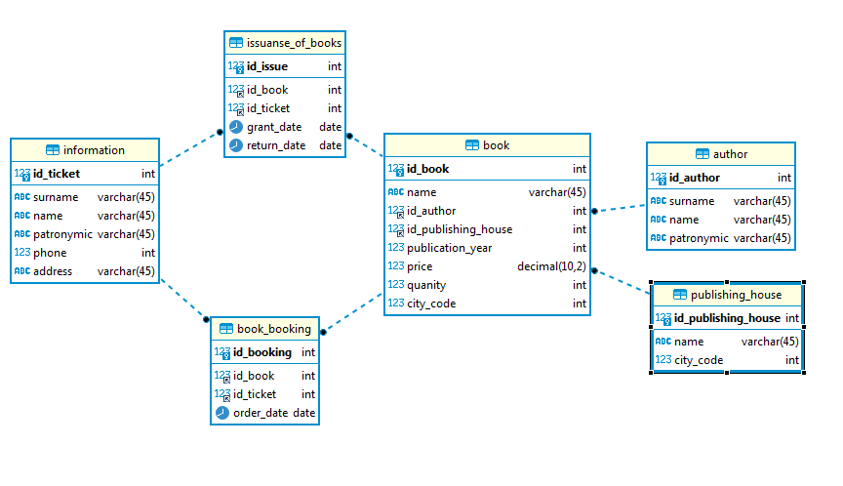

drop database if exists library;
create database library;
use library;
DROP TABLE IF EXISTS information;
CREATE TABLE information (
id_ticket int NOT NULL auto_increment PRIMARY KEY,
surname varchar(45),
name varchar(45),
patronymic varchar(45),
phone int(10),
address varchar(45)
);
DROP TABLE IF EXISTS author;
CREATE TABLE author (
id_author int NOT NULL auto_increment PRIMARY KEY,
surname varchar(45),
name varchar(45),
patronymic varchar(45)
);
DROP TABLE IF EXISTS publishing_house;
CREATE TABLE publishing_house (
id_publishing_house int NOT NULL auto_increment PRIMARY KEY,
name varchar(45),
city_code int(10)
);
DROP TABLE IF EXISTS book;
CREATE TABLE book (
id_book int NOT NULL auto_increment PRIMARY KEY,
name varchar(45),
id_author int NOT NULL,
id_publishing_house int NOT NULL,
publication_year int,
price decimal(10,2),
quanity int(40),
city_code int(10),
FOREIGN KEY (id_author) REFERENCES author (id_author)
on delete cascade
on update cascade,
FOREIGN KEY (id_publishing_house) REFERENCES publishing_house (id_publishing_house)
on delete cascade
on update cascade
);
DROP TABLE IF EXISTS issuanse_of_books;
CREATE TABLE issuanse_of_books (
id_issue int NOT NULL auto_increment PRIMARY KEY,
id_book int NOT NULL,
id_ticket int NOT NULL,
grant_date date,
return_date date,
FOREIGN KEY (id_book) REFERENCES book (id_book)
on delete cascade
on update cascade,
FOREIGN KEY (id_ticket) REFERENCES information (id_ticket)
on delete cascade
on update cascade
);
DROP TABLE IF EXISTS book_booking;
CREATE TABLE book_booking (
id_booking int NOT NULL auto_increment PRIMARY KEY,
id_book int NOT NULL,
id_ticket int NOT NULL,
order_date date,
FOREIGN KEY (id_book) REFERENCES book (id_book)
on delete cascade
on update cascade,
FOREIGN KEY (id_ticket) REFERENCES information (id_ticket)
on delete cascade
on update cascade
);

